12.40: At the equator, the gravitational field and the radial acceleration are parallel, and taking the magnitude of the weight as given in Eq. (12.30) gives

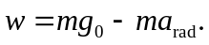

The difference between the measured weight and the force of gravitational attraction is the term 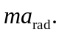 The mass is found by solving the first relation for 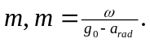Then,

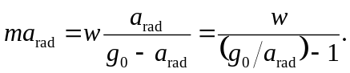

Using either 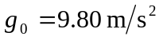or calculating 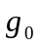from Eq. (12.4) gives 